**PROJECT REPORT ON SPORTS CLUB MANAGEMENT SYSTEM**

**Submitted By:**

**Vasu**

**XIIth**

**Green Fields Public School**

**Coding**

//**********************************************************

// PROJECT SPORTS CLUB MANAGEMENT

//**********************************************************

//**********************************************************

// INCLUDED HEADER FILES

//**********************************************************

#include<fstream.h>

#include<iostream.h>

#include<iomanip.h>

#include<conio.h>

#include<stdio.h>

#include<process.h>

int code2,code3,code4,code5,code6;

int i=0,j,temp,day,nba,nba1,t=0,p=0;

char ch,ch5,ch6,chi1,chi2,chi3,opt;

//**********************************************************

// CLASS NAME : CLUB

// DETAILS : IT CONTROLS OVER ALL THE FUNCTIONS

//**********************************************************

class club

{

char code,ch1,ch2,ch3;

int code1,flag;

float amt,no;//amt->amount deposited for membership

long telno1,telno2;//office and residential telephone nos. respectively

char addr[40],addr1[40];//addr->residential,addr1->office

char name[20];//name of the member

char c1,c2,c3,c4,c5,c6;//date variables for membership dates

char d1,d2,d3,d4,d5,d6;//date variables for submission of fees

float due;//gives the fees due

public: int retcode1()

{

return code1;//member's code

}

void instruct();//displays the instructions on the screen

void input();//gets the details of the member

void menu();//creates main menu and calls other functions

void back();//gives choice to the user to go back to main menu

void print();//displays the details of the member on the screen

void show();// displays the details of the member and the fees due

//(FOR LISTING OF MEMBERS)

void func1a();//for registration of a new member

void func1b();//for modification in member's information

void func1c();//for deletion of records of members who have left

void func1d();//search for the info of a memberwhose code is known

void func1e();//activity wise member code and name

void func1f();//info about all members of the club

//(FOR STATEMENT OF FEES)

void func3a();//datewise fees collected from members

void func3b();//list of members whose fees is due

//(FOR EXMEMBERS INFORMATION)

void func4a();//information of exmember

void func4b();//recover deleted data(member rejoining)

};

club ob[10],ob1;

//****************************************************************

// THIS FUNCTION GIVES CHOICE TO THE USER TO GO BACK TO MAIN MENU

//****************************************************************

void club::back()

{

cout<<"\nDO YOU WANT TO GO BACK TO THE MAIN MENU: ";

cin>>ch2;

if(ch2=='y'||ch2=='Y')

menu();

else exit(0);

}

//*******************************************************

// THIS FUNCTION DISPLAYS THE INSTRUCTIONS ON THE SCREEN

//*******************************************************

void club::instruct()

{

cout<<"\nWELCOME TO ";

cout<<endl;

cout<<setw(53)<<"SPORTS CLUB MANAGEMENT SYSTEM\n";

cout<<setw(52)<<" ~~~~~~~~~~~~~~~~~~~~~~~~~~~~~";

cout<<endl<<endl;

cout<<" INSTRUCTIONS ";

cout<<endl;

cout<<"\n(1) IF YOU DON'T OPT TO GO BACK TO MAIN MENU THE PROG. TERMINATES";

cout<<"\n(2) THE FORMAT OF DATE SHOULD BE DD/MM/YY";

cout<<"\n(3) AMOUNT TO BE DEPOSITED BETWEEN Rs. 1.00 & 7000.00";

cout<<"\n(4) THE DELETED DATA IS STORED IN DEL.TXT FILE ";

cout<<"\n(5) THE FEE FILE CONTAINS DATA OF THOSE WHOSE FEE IS DUE";

cout<<"\n(6) FACILITY CODES EXIST BETWEEN 1-6";

cout<<"\n\n";

cout<<"PRESS A KEY TO CONTINUE";

getche();

}

//*****************************************

// THIS FUNCTION GTS THE INPUT OF A MEMBER

//*****************************************

void club::input()

{

clrscr();

cout<<setw(53)<<"SPORTS CLUB MANAGEMENT SYSTEM\n";

cout<<setw(52)<<" ~~~~~~~~~~~~~~~~~~~~~~~~~~~~~";

cout<<"\nPLEASE FILL IN THE FOLLOWING INFORMATION " ;

cout<<"\n\nMEMBERS CODE : ";

cin>>code1;

cout<<"MEMBERS NAME : ";

gets(name);

cout<<"DATE : / / ";

gotoxy(16,7);

c1=getche();

gotoxy(17,7);

c2=getche();

gotoxy(19,7);

c3=getche();

gotoxy(20,7);

c4=getche();

gotoxy(22,7);

c5=getche();

gotoxy(23,7);

c6=getche();

cout<<"\n\nADDRESS : ";

cout<<"\n\t\tRESIDENTIAL\t\t\tOFFICIAL";

cout<<"\n\t\t~~~~~~~~~~~\t\t\t~~~~~~~~";

gotoxy(10,13);

cout<<"->";

gets(addr);

gotoxy(43,13);

cout<<"->";

gets(addr1);

cout<<"\n\nPHONE NUMBER : ";

cout<<"\nOFFICE : ";cin>>telno1;

cout<<"RESIDENCE : ";cin>>telno2;

cout<<"\n FACILITY CODES";

cout<<"\n(1) SWIMMING \t\t(2) TENNIS\t\t(3) SQUASH\t\t(4) ALL";

cout<<"\n(5) 1 & 2 \t\t(6) 2 & 3\t\t(7) 1 & 3 "<<endl;

cout<<"\nINPUT FACILITY CODE : ";

cin>>code;

cout<<"\nFEE SUBMITTED ON : / / ";

gotoxy(19,25);

d1=getche();

gotoxy(20,25);

d2=getche();

gotoxy(22,25);

d3=getche();

gotoxy(23,25);

d4=getche();

gotoxy(25,25);

d5=getche();

gotoxy(26,25);

d6=getche();

cout<<"\nAMOUNT DEPOSITED (IN RS.) : ";

cin>>amt;

flag=0;

}

//**********************************************************

// THIS FUNCTION CREATE MAIN MENU AND CALLS OTHER FUNCTIONS

//**********************************************************

void club::menu()

{

alm:clrscr();

cout<<setw(53)<<"SPORTS CLUB MANAGEMENT SYSTEM\n";

cout<<setw(52)<<" ~~~~~~~~~~~~~~~~~~~~~~~~~~~~~";

cout<<endl<<endl;

cout<<setw(40)<<"MENU\n\n";

cout<<" (1) LISTING OF MEMBERS\n";

cout<<" (2) FACILITY FILE\n";

cout<<" (3) STATEMENT OF FEES\n";

cout<<" (4) EXMEMBER'S INFORMATION\n";

cout<<" (5) EXIT THE PROGRAM\n";

cout<<endl<<endl;

cout<<"INPUT YOUR CHOICE : ";

cin>>ch1;

if(ch1=='1')

{

clrscr();

cout<<"\nYOU HAVE CHOSEN OPTION 1\n";

cout<<endl<<endl;

cout<<" LISTING OF MEMBERS\n";

cout<<endl<<endl;

cout<<"(1) REGISTRATION OF NEW MEMBER \n";

cout<<"(2) MODIFICATIONS IN MEMBERS INFORMATION\n";

cout<<"(3) DEL. OF RECORD FOR THE MEMBER WHO HAS LEFT\n";

cout<<"(4) SEARCHING FOR THE INFO. OF A MEMBER WHOSE ONE OF THE MAIN FIELD IS KNOWN\n";

cout<<"(5) ACTIVITY WISE MEMBERS CODE AND NAME\n";

cout<<"(6) INFORMATION ABOUT ALL THE MEMBERS OF THE CLUB\n";

cout<<endl<<endl;

cout<<"INPUT THE OPTION : ";

cin>>ch3;

switch(ch3)

{

case '1':func1a();

case '2':func1b();

case '3':func1c();

case '4':func1d();

case '5':func1e();

case '6':func1f();

}

}

if(ch1=='2')

{

clrscr();

cout<<"\nYOU HAVE CHOSEN OPTION 2\n";

cout<<endl<<endl;

cout<<" FACILITY FILE\n";

cout<<"\nLIST OF THE FACILITIES AVAILABLE IN THE CLUB\n";

cout<<endl<<endl;

cout<<"PRESS A KEY TO CONTINUE ";

getch();

cout<<"\nTHE VARIOUS COMBINATIONS OF FACILITIES AVAIL. ARE AS FOLLOWS";

cout<<endl<<endl;

cout<<"~~~~~~~~~~~~~~~~~~~~~~~~~~~~~~~~~~~~~~~~~~~~~~~~~~~~~~~~~~~~~~~~~";

cout<<"\nFACILITY CODE FACILITY";

cout<<"\n~~~~~~~~~~~~~~~~~~~~~~~~~~~~~~~~~~~~~~~~~~~~~~~~~~~~~~~~~~~~~~~";

cout<<"\n (1) SWIMMING";

cout<<"\n (2) TENNIS";

cout<<"\n (3) SQUASH";

cout<<"\n (4) ALL";

cout<<"\n (5) 1 & 2";

cout<<"\n (6) 2 & 3";

cout<<"\n (7) 1 & 3 ";

cout<<endl;

cout<<"~~~~~~~~~~~~~~~~~~~~~~~~~~~~~~~~~~~~~~~~~~~~~~~~~~~~~~~~~~~~~~~~~~";

cout<<"\nDO YOU WANT TO GO BACK TO THE MAIN MENU: ";

cin>>ch2;

if(ch2=='y'||ch2=='Y')

goto alm;

}

if(ch1=='3')

{

clrscr();

cout<<"\nYOU HAVE CHOSEN OPTION 3\n";

cout<<endl<<endl;

cout<<" STATEMENT OF FEES\n";

cout<<endl<<endl;

cout<<"(1) DATEWISE FEES COLLECTED FROM MEMBERS \n";

cout<<"(2) LIST OF MEMBERS WHOSE FEES IS DUE \n";

cout<<endl<<endl;

cout<<"INPUT THE CHOICE : ";

cin>>chi2;

switch(chi2)

{

case '1':func3a();

case '2':func3b();

}

}

if(ch1=='4')

{

clrscr();

cout<<"\nYOU HAVE CHOSEN OPTION 4\n";

cout<<endl<<endl;

cout<<" EXMEMBERS INFORMATION\n";

cout<<endl<<endl;

cout<<"\n(1) INFORMATION OF EXMEMBER'S";

cout<<"\n(2) RECOVER DELETED DATA (MEM. REJOINING)";

cout<<"\nINPUT THE CHOICE : ";

cin>>chi3;

switch(chi3)

{

case '1':func4a();

case '2':func4b();

}

}

if(ch1=='5')

{

clrscr();

cout<<endl<<endl;

cout<<"\t\t\tPRESS A KEY TO EXIT : ";

getche();

exit(0);

}

}

//**************************************************

// THIS FUNCTION DISPLAYS PARTICULARS OF A MAMBERER

//**************************************************

void club::print()

{

clrscr();

cout<<setw(53)<<"SPORTS CLUB MANAGEMENT SYSTEM\n";

cout<<setw(52)<<" ~~~~~~~~~~~~~~~~~~~~~~~~~~~~~";

cout<<"\n\nMEMBERS CODE : ";

cout<<code1;

cout<<"\nMEMBERS NAME : ";

puts(name);

cout<<"\nDATE : / / ";

gotoxy(16,7);

putch(c1);

gotoxy(17,7);

putch(c2);

gotoxy(19,7);

putch(c3);

gotoxy(20,7);

putch(c4);

gotoxy(22,7);

putch(c5);

gotoxy(23,7);

putch(c6);

cout<<"\n\nADDRESS : ";

cout<<"\n\t\tRESIDENTIAL\t\t\tOFFICIAL";

cout<<"\n\t\t~~~~~~~~~~~\t\t\t~~~~~~~~";

gotoxy(10,14);

cout<<"->";

puts(addr);

gotoxy(43,14);

cout<<"->";

puts(addr1);

cout<<"\nPHONE NUMBERS ";

cout<<"\nOFFICE : ";

cout<<telno1;

cout<<"\nRESIDENCE : ";

cout<<telno2;

cout<<"\n FACILITY CODES";

cout<<"\n(1) SWIMMING \t\t(2) TENNIS\t\t(3) SQUASH\t\t(4) ALL";

cout<<"\n(5) 1 & 2 \t\t(6) 2 & 3\t\t(7) 1 & 3 "<<endl;

cout<<"\nFACILITY CODE : ";

cout<<code;

cout<<"\nFEE SUBMITTED ON : / / ";

gotoxy(19,24);

putch(d1);

gotoxy(20,24);

putch(d2);

gotoxy(22,24);

putch(d3);

gotoxy(23,24);

putch(d4);

gotoxy(25,24);

putch(d5);

gotoxy(26,24);

putch(d6);

cout<<"\nAMOUNT DEPOSITED (IN RS.) : ";

cout<<amt;

getch();

}

//******************************************

// THIS FUNCTION GIVES FEES DUE OF A MEMBER

//******************************************

void club::show()

{

clrscr();

cout<<setw(53)<<"SPORTS CLUB MANAGEMENT SYSTEM\n";

cout<<setw(52)<<" ~~~~~~~~~~~~~~~~~~~~~~~~~~~~~";

cout<<"\n\nMEMBERS CODE : ";

cout<<code1;

cout<<"\nMEMBERS NAME : ";

puts(name);

cout<<"\nDATE : / / ";

gotoxy(16,7);

putch(c1);

gotoxy(17,7);

putch(c2);

gotoxy(19,7);

putch(c3);

gotoxy(20,7);

putch(c4);

gotoxy(22,7);

putch(c5);

gotoxy(23,7);

putch(c6);

cout<<"\n\nADDRESS : ";

cout<<"\n\t\tRESIDENTIAL\t\t\tOFFICIAL";

cout<<"\n\t\t~~~~~~~~~~~\t\t\t~~~~~~~~";

gotoxy(10,14);

cout<<"->";

puts(addr);

gotoxy(43,14);

cout<<"->";

puts(addr1);

cout<<"\nPHONE NUMBERS ";

cout<<"\nOFFICE : ";

cout<<telno1;

cout<<"\nRESIDENCE : ";

cout<<telno2;

cout<<"\n FACILITY CODES";

cout<<"\n(1) SWIMMING \t\t(2) TENNIS\t\t(3) SQUASH\t\t(4) ALL";

cout<<"\n(5) 1 & 2 \t\t(6) 2 & 3\t\t(7) 1 & 3 "<<endl;

cout<<"\nFACILITY CODE : ";

cout<<code;

cout<<"\nFEE SUBMITTED ON : / / ";

gotoxy(19,24);

putch(d1);

gotoxy(20,24);

putch(d2);

gotoxy(22,24);

putch(d3);

gotoxy(23,24);

putch(d4);

gotoxy(25,24);

putch(d5);

gotoxy(26,24);

putch(d6);

cout<<"\nAMOUNT DEPOSITED (IN RS.) : ";

cout<<amt;

cout<<"\nFEES DUE IS : ";

cout<<due;

getch();

}

//**************************************

// THIS FUNCTION REGISTERS A NEW MEMBER

//**************************************

void club::func1a()

{

if(ch3=='1')

{

clrscr();

cout<<"\nYOU HAVE CHOSEN OPTION 1\n";

cout<<endl<<endl;

cout<<"(1) REGISTRATION OF NEW MEMBER \n";

cout<<endl<<endl;

cout<<"PRESS A KEY TO CONTINUE : ";

getche();

fstream f1("project.txt",ios::ate|ios::in|ios::binary);

fstream f2("project.txt",ios::out|ios::app|ios::in|ios::binary);

do

{

if(f2.eof())break;

ob[i].input();

f2.write((char*)&ob[i++],sizeof(ob[i++]));

cout<<endl;

cout<<endl<<endl;

cout<<"DO YOU WANT TO INPUT MORE INFORMATION(Y/N) = ";

ch=getche();

}

while(ch=='y'||ch=='Y');

}

back();

}

//****************************************************

// THIS FUNCTION IS USED TO MODIFY RECORD OF A MEMBER

//****************************************************

void club::func1b()

{

if(ch3=='2')

{

clrscr();

cout<<"\nYOU HAVE CHOSEN OPTION 2\n";

cout<<endl<<endl;

cout<<"(2) MODIFICATIONS IN MEMBER'S INFORMATION\n";

cout<<endl<<endl;

cout<<"PRESS A KEY TO CONTINUE : ";

getche();

take1:cout<<"PLEASE ENTER THE CODE NO OF THE MEMBER WHOSE DATA IS TO BE MODIFIED = ";

cin>>code4;

cout<<endl<<endl;

fstream f1("project.txt",ios::ate|ios::in|ios::binary);

for(j=0;j<i;j++)

{

f1.read((char*)&ob[j],sizeof(ob[j]));

if(code4==ob[j].code1 && ob[j].flag==0)

{

cout<<"\n\n\nTHE CODE CHOSEN IS =: "<<code4;

cout<<"\n\n\nPRESS ENTER TO CONTINUE : ";

getche();

cout<<"\n(1)CHANGE IN MEMBERS RES. ADDRESS ";

cout<<"\n(2)CHANGE IN MEMBERS OFF. ADDRESS ";

cout<<"\n(3)CHANGE IN MEMBERS OFF. PHONE NO. ";

cout<<"\n(4)CHANGE IN MEMBERS RES. PHONE NO. ";

cout<<"\n(5)CHANGE IN MEMBERS FACILITY CODE ";

cout<<"\n\nINPUT OPTION = " ;

cin>>opt;

if(opt=='1')

{

clrscr();

cout<<"\t\t\tYOU HAVE CHOSEN OPTION A " ;

cout<<"\n\nCHANGE IN MEMBERS RES. ADDRESS ";

f1.seekg(+22,ios::end);

cout<<"\n\nTHE OLD ADDRESS OF THE MEMBER IS = ";

puts(ob[j].addr);

cout<<"\n\nINPUT THE NEW ADDRESS OF THE MEMBER = ";

gets(ob[j].addr);

f1.write((char*)&ob[j].addr,sizeof(ob[j].addr));

cout<<"THE DATA OF THE MEMBER WITH THE CHANGED ADDRESS IS: ";

ob[j].print();

}

if(opt=='2')

{

clrscr();

cout<<"\t\t\tYOU HAVE CHOSEN OPTION 2 " ;

cout<<"\n\nCHANGE IN MEMBERS OFF. ADDRESS ";

f1.seekg(+21,ios::end);

cout<<"\n\nTHE OLD OFF. ADDRESS OF THE MEMBER IS = ";

puts(ob[j].addr1);

cout<<"\n\nINPUT THE NEW ADDRESS OF THE MEMBER = ";

gets(ob[j].addr1);

f1.write((char*)&ob[j].addr1,sizeof(ob[j].addr1));

cout<<"THE DATA OF THE MEMBER WITH THE CHANGED ADDRESS IS: ";

ob[j].print();

}

if(opt=='3')

{

clrscr();

cout<<"\t\t\tYOU HAVE CHOSEN OPTION 3 " ;

cout<<"\n\nCHANGE IN MEMBERS OFF. PHONE NO. ";

f1.seekg(+20,ios::end);

cout<<"\n\nTHE OLD OFF. PHONE NO OF THE MEMBER IS = ";

cout<<ob[j].telno1;

cout<<"\n\nINPUT THE NEW OFF. PHONE NO OF THE MEMBER = ";

cin>>ob[j].telno1;

f1.write((char*)&ob[j].telno1,sizeof(ob[j].telno1));

cout<<"THE DATA OF THE MEMBER WITH THE CHANGED OFF. PHONE NO IS: ";

ob[j].print();

}

if(opt=='4')

{

clrscr();

cout<<"\t\t\tYOU HAVE CHOSEN OPTION 4 " ;

cout<<"\n\nCHANGE IN MEMBERS RES. PHONE NO ";

f1.seekg(+16,ios::end);

cout<<"\n\nTHE OLD RES. PHONE NO OF THE MEMBER IS = ";

cout<<ob[j].telno2;

cout<<"\n\nINPUT THE NEW RES. PHONE NO OF THE MEMBER = ";

cin>>ob[j].telno2;

f1.write((char*)&ob[j].telno2,sizeof(ob[j].telno2));

cout<<"THE DATA OF THE MEMBER WITH THE CHANGED RES. PHONE NO IS: ";

ob[j].print();

}

if(opt=='5')

{

clrscr();

cout<<"\t\t\tYOU HAVE CHOSEN OPTION 5 " ;

cout<<"\n(5)CHANGE IN MEMBERS FACILITY CODE ";

f1.seekg(+12,ios::end);

cout<<"\n\nTHE OLD FACILITY CODE OF THE MEMBER IS = ";

cout<<ob[j].code;

cout<<"\nFOR REFERING TO CODES,CHOSE THE FACILITY FILE OPTION ";

cout<<"\n\nINPUT THE NEW FACILITY CODE OF THE MEMBER = ";

cin>>ob[j].code;

f1.write((char*)&ob[j].code,sizeof(ob[j].code));

cout<<"THE DATA OF THE MEMBER WITH THE CHANGED FACILITY CODE IS: ";

ob[j].print();

}

cout<<endl<<endl<<endl;

cout<<"DO YOU WANT TO MODIFY ANY OTHER MEMBERS INFORMATION(Y/N) : ";

cin>>chi1;

if(chi1=='y'||chi1=='Y')

{

clrscr();

goto take1;

}

else back();

}

}

}

cout<<endl<<endl<<endl;

back();

}

//********************************************

// THIS FUNCTION DELETES THE RECORD OF MEMBER

//********************************************

void club::func1c()

{

if(ch3=='3')

{

clrscr();

cout<<"\nYOU HAVE CHOSEN OPTION 3\n";

cout<<endl<<endl;

cout<<"(3) DEL. OF RECORD FOR THE MEMBER WHO HAS LEFT\n";

cout<<endl<<endl;

cout<<"PRESS A KEY TO CONTINUE : ";

getche();

cout<<"INPUT THE CODE NO. OF THE MEMBER WHOSE DATA YOU WANT TO DELETE = ";

cin>>code2;

fstream f1("project.txt",ios::ate|ios::in|ios::binary);

for(j=0;j<i;j++)

{

f1.read((char*)&ob[j],sizeof(ob[j]));

if(code2==ob[j].code1 && ob[j].flag==0)

{

ob[j].flag=1;

cout<<"\nTHE INFORMATION IS NOW DELETED BUT CAN BE RECOVERED ";

cout<<"\nPRESS A KEY TO VIEW THE DELETED INFORMATION ";

getch();

ob[j].print();

}

else if(code2==ob[j].code1 && flag==1)

cout<<"\nTHE DATA IS ALREADY DELETED";

}

}

back();

}

//**************************************

// THIS FUNCTION SEARCHES FOR THE MEMBER

//**************************************

void club::func1d()

{

if(ch3=='4')

{

clrscr();

cout<<"\nYOU HAVE CHOSEN OPTION 4\n";

cout<<endl<<endl;

cout<<"(4) SEARCHING FOR THE INFO. OF A MEMBER WHOSE ONE OF THE MAIN FIELD IS KNOWN\n";

cout<<endl<<endl;

cout<<"\nPRESS A KEY TO CONTINUE : ";

getche();

do

{

cout<<"\nINPUT THE CODE NO. OF THE MEMBER WHOSE DATA YOU WANT = ";

cin>>code3;

fstream f1("project.txt",ios::ate|ios::in|ios::binary);

for(j=0;j<i;j++)

{

f1.read((char*)&ob[j],sizeof(ob[j]));

if(code3==ob[j].retcode1() && ob[j].flag==0)

{

cout<<"A MATCH HAS BEEN FOUND :";

cout<<"\n\nPRESS A KEY TO CONTINUE : ";

getch();

ob[j].print();

}

}

cout<<endl;

cout<<"\nDO YOU WANT TO SEARCH FOR ANY OTHER MEMBER (Y/N)= ";

ch=getche();

}

while(ch=='y'||ch=='Y');

}

back();

}

//************************************************************

// THIS FUNCTION DISPLAYS ACTIVITY WISE MEMBERS CODE AND NAME

//************************************************************

void club::func1e()

{

if(ch3=='5')

{

clrscr();

cout<<"\nYOU HAVE CHOSEN OPTION 5\n";

cout<<endl<<endl;

cout<<"(5) ACTIVITY WISE MEMBERS CODE AND NAME\n"; cout<<endl<<endl;

cout<<"\nPRESS A KEY TO CONTINUE : ";

getche();

cout<<"THE VARIOUS COMBINATIONS OF ACTIVITIES AVAILABLE IN ";

cout<<"THE CLUB ARE GIVEN BELOW :";

cout<<"\n(1) SWIMMING \t\t(2) TENNIS\t\t(3) SQUASH\t\t(4) ALL";

cout<<"\n(5) 1 & 2 \t\t(6) 2 & 3\t\t(7) 1 & 3 "<<endl;

cout<<"\nPRESS ENTER TO VIEW THE NAMES & CODES OF MEMBERS UNDER EACH ACTIVITY";

getch();

clrscr();

fstream f1("project.txt",ios::ate|ios::in|ios::binary);

cout<<"\n~~~~~~~~~~~~~~~~~~~~~~~~~~~~~~~~~~~~~~~~~~~~~~~~~~~~~~~~~~~~~~~~~~~~~~~~~~~~~~~";

cout<<"\nFAC. CODE \t\t MEM. CODE NO \t\t NAME ";

cout<<"\n~~~~~~~~~ \t\t ~~~~~~~~~~~~ \t\t ~~~~";

cout<<"\n~~~~~~~~~~~~~~~~~~~~~~~~~~~~~~~~~~~~~~~~~~~~~~~~~~~~~~~~~~~~~~~~~~~~~~~~~~~~~~";

cout<<endl;

for(j=0;j<i;j++)

f1.read((char*)&ob[j],sizeof(ob[j]));

for(j=0;j<i-1;j++)

for(int k=j+1;k<i;k++)

if(ob[j].code>ob[k].code)

{

temp=ob[j].code;

ob[j].code=ob[k].code;

ob[k].code=temp;

}

for(j=0;j<i;j++)

{

cout<<setw(8)<<ob[j].code<<" \t\t\t\t "<<ob[j].retcode1()<<"\t\t\t\t";puts(ob[j].name);

cout<<"\n";

}

cout<<"\n~~~~~~~~~~~~~~~~~~~~~~~~~~~~~~~~~~~~~~~~~~~~~~~~~~~~~~~~~~~~~~~~~~~~~~~~~~~~~~~~~";

}

cout<<endl<<endl;

back();

}

//**********************************************************************

// THIS FUNCTION DISPLAYS INFORMATION ABOUT ALL THE MEMBERS OF THE CLUB

//**********************************************************************

void club::func1f()

{

if(ch3=='6')

{

clrscr();

cout<<"\nYOU HAVE CHOSEN OPTION 6\n";

cout<<endl<<endl;

cout<<"(6) INFORMATION ABOUT ALL THE MEMBERS OF THE CLUB\n";

cout<<"\nPRESS A KEY TO CONTINUE : ";

getche();

fstream f1("project.txt",ios::ate|ios::in|ios::binary);

for(j=0;j<i;j++)

{

f1.read((char*)&ob[j],sizeof(ob[j]));

if(ob[j].flag==0)

ob[j].print();

}

}

cout<<endl<<endl;

back();

}

//*************************************************

// THIS FUNCTION DISPLAYS DATE WISE FEES COLLECTED

//*************************************************

void club::func3a()

{

if(chi2=='1')

{

clrscr();

cout<<"\nYOU HAVE CHOSEN OPTION 1";

cout<<"\n(1) DATEWISE FEES COLLECTED FROM MEMBERS \n";

cout<<"\n\n\n\n";

cout<<"INPUT THE CODE NO. OF THE MEMBER : ";

cin>>nba;

fstream f1("project.txt",ios::ate|ios::in|ios::binary);

fstream mf("feefile.txt",ios::out|ios::app|ios::in|ios::binary);

for(j=0;j<i;j++)

{

f1.read((char*)&ob[j],sizeof(ob[j]));

if(nba==ob[j].code1 && ob[j].flag==0)

{

clrscr();

cout<<"\n\n\nTHE CODE CHOSEN IS =: "<<nba;

cout<<"\nYOU ARE ";puts(ob[j].name);

cout<<"\nYOU HAD DEPOSITED RS.: "<<ob[j].amt;

cout<<"\nFEE SUBMITTED ON : / / ";

gotoxy(19,8);

putch(ob[j].d1);

gotoxy(20,8);

putch(ob[j].d2);

gotoxy(22,8);

putch(ob[j].d3);

gotoxy(23,8);

putch(ob[j].d4);

gotoxy(25,8);

putch(ob[j].d5);

gotoxy(26,8);

putch(ob[j].d6);

cout<<"\nTHE AMOUNT FOR 30 DAYS IS RS. 3500";

cout<<"\nENTER THE NUMBER OF DAYS AFTER WHICH YOU ARE DEPOSITING THE AMT.:";

cin>>day;

cout<<"\n\n\nPRESS ENTER TO CONTINUE : ";

getche();

cout<<endl<<endl;

if(day<30 && ob[j].amt>=3500)

cout<<"\n\n NO AMOUNT DUE. ";

else if(day==30 && ob[j].amt>3500)

cout<<"\n\n NO AMOUNT DUE. ";

else if(day>=30 && ob[j].amt<3500)

{

cout<<"\n\nYOUR AMOUNT IS DUE : ";

cout<<"\nTRANSFERRING CONTROLLES";

ob[j].due=3500-ob[j].amt;

cout<<"\nPRESS A KEY TO CONTINUE: ";

getche();

cout<<"\nTHE AMOUNT DUE IS RS. "<<ob[j].due;

mf.write((char*)&ob[j],sizeof(ob[j]));

t++;

}

else if(day>=60 && ob[j].amt<7000)

{

cout<<"\t\t\t\t\nWARNING..";

cout<<"\n\nYOUR AMOUNT IS DUE : ";

cout<<"\nTRANSFERRING CONTROLLES";

ob[j].due=7000-ob[j].amt;

cout<<"\nPRESS A KEY TO CONTINUE: ";

getche();

cout<<"\nTHE AMOUNT DUE IS RS. "<<ob[j].due;

mf.write((char*)&ob[j],sizeof(ob[j]));

t++;

}

else if(day>60 && ob[j].amt<3500)

{

cout<<"\t\t\t\t\nWARNING..";

cout<<"\n\nYOUR AMOUNT IS DUE : ";

cout<<"\nTRANSFERRING CONTROLLES";

ob[j].due=10500-ob[j].amt;

cout<<"\nPRESS A KEY TO CONTINUE: ";

getche();

cout<<"\nTHE AMOUNT DUE IS RS. "<<ob[j].due;

mf.write((char*)&ob[j],sizeof(ob[j]));

t++;

}

}

}

}

cout<<endl<<endl;

back();

}

//**********************************************************

// THIS FUNCTION DISPLAYS LIST OF MEMBERS WHOSE FEES IS DUE

//**********************************************************

void club::func3b()

{

if(chi2=='2')

{

clrscr();

cout<<"\nYOU HAVE CHOSEN OPTION 2";

cout<<"\n(B) LIST OF MEMBERS WHOSE FEES IS DUE\n";

cout<<"\n\n\n\n";

getche();

fstream mf("feefile.txt",ios::ate|ios::in|ios::binary);

for(j=0;j<t;j++)

if(ob[j].flag==0)

{

mf.read((char*)&ob[j],sizeof(ob[j]));

ob[j].show();

}

}

back();

}

//************************************************

// THIS FUNCTION DISPLAYS INFOMATION OF EXMEMBERS

//************************************************

void club::func4a()

{

if(chi3=='1')

{

clrscr();

cout<<"\nYOU HAVE CHOSEN OPTION 1";

cout<<"\n\n\n\n";

cout<<"\n(1) INFORMATION OF EXMEMBERS";

cout<<"\nINPUT THE CODE NO. OF THE EXMEMBER WHOSE INFO. YOU WANT: ";

cin>>code5;

fstream f1("project.txt",ios::ate|ios::in|ios::binary);

for(j=0;j<i;j++)

{

f1.read((char*)&ob[j],sizeof(ob[j]));

if(code5==ob[j].code1 && ob[j].flag==1)

{

cout<<"\nA MATCH HAS BEEN FOUND :";

cout<<"\n\nPRESS A KEY TO CONTINUE : ";

getch();

ob[j].print();

}

}

}

back();

}

//**********************************************************

// THIS FUNCTION IS USED TO MAKE AN EXMEMBER A MEMBER AGAIN

//**********************************************************

void club::func4b()

{

if(chi3=='2')

{

a:clrscr();

cout<<"\nYOU HAVE CHOSEN OPTION 2";

cout<<"\n\n\n\n";

cout<<"\n(2) RECOVER DELETED DATA (MEM. REJOINING)";

cout<<"\nINPUT THE CODE NO. OF THE EXMEMBER : ";

cin>>code6;

fstream f1("project.txt",ios::ate|ios::in|ios::binary);

for(j=0;j<i;j++)

{

f1.read((char*)&ob[j],sizeof(ob[j]));

if(code6==ob[j].code1 && ob[j].flag==1)

{

cout<<"\nA MATCH HAS BEEN FOUND :";

cout<<"\nTRANSFERING CONTROLS";

ob[j].flag=0;

cout<<"\n\nPRESS A KEY TO CONTINUE : ";

getch();

ob[j].print();

cout<<"\nYOU ARE NOW A MEMBER OF THIS CLUB ";

}

}

cout<<"\nDO YOU WANT TO CONTINUE :(Y/N): ";

cin>>ch6;

if(ch6=='y'||ch6=='Y')

goto a;

}

cout<<endl<<endl;

back();

}

//**********************************************************

// THIS FUNCTION IS THE MAIN FUNCTION CALLING THE MAIN MENU

//**********************************************************

void main()

{

ob1.instruct();

ob1.menu();

getch();

}

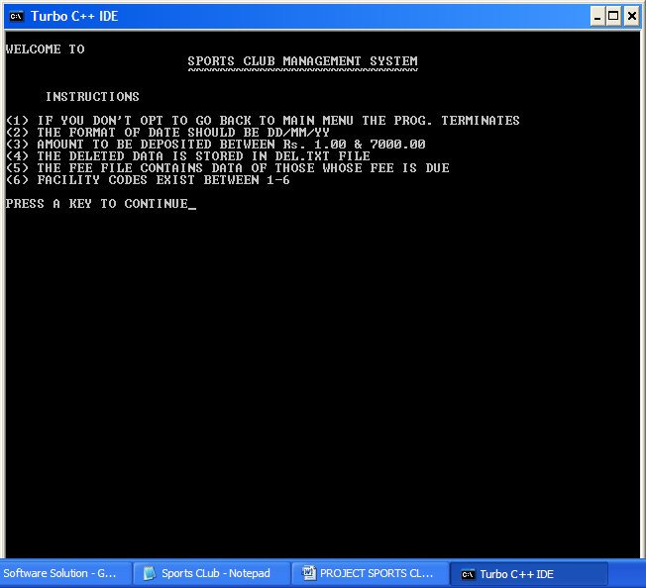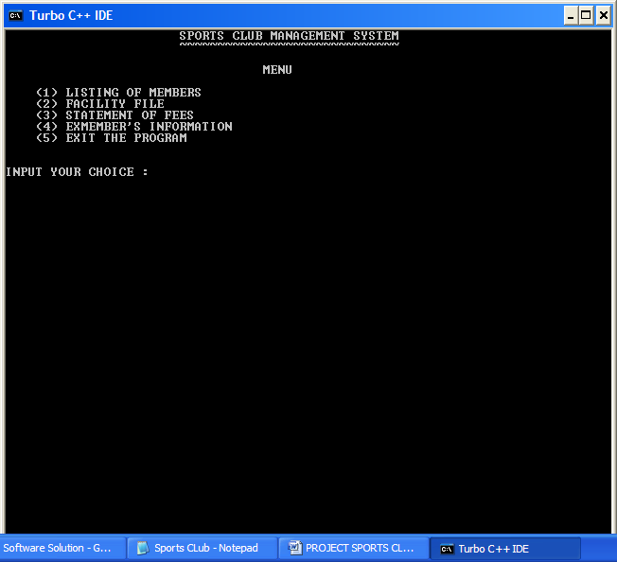

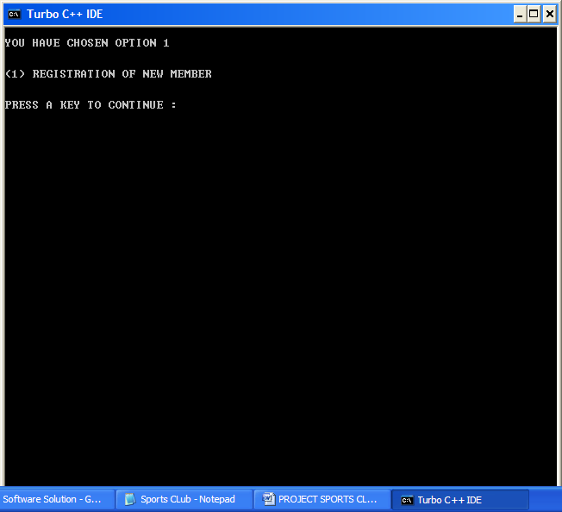

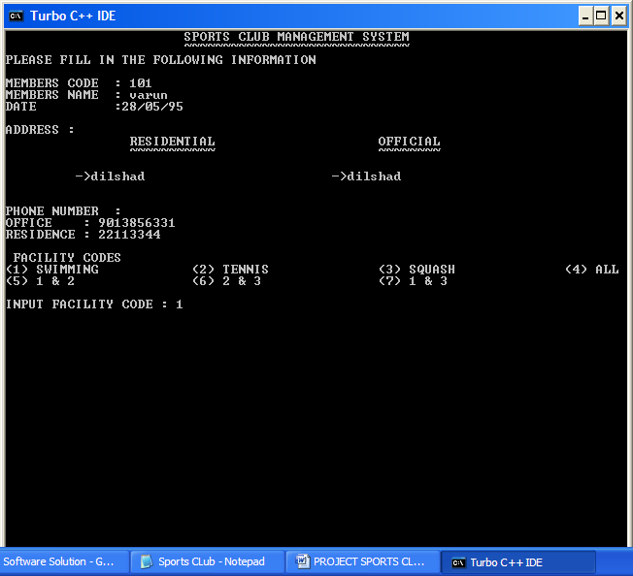

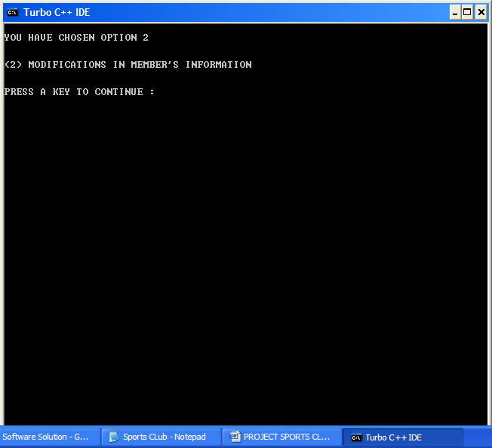

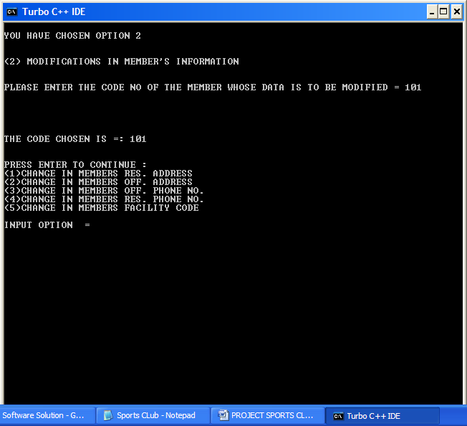

Bibliography

* XI-Computer Science, Sumita Arora
* XII- Computer Science, Sumita Arora
* Together with Computer Science